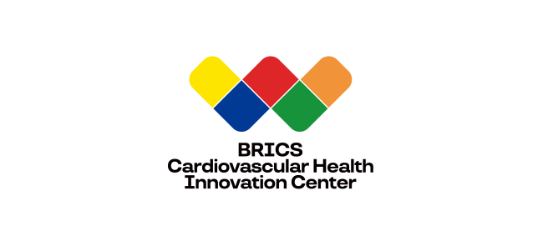 BRICS Cardiovascular Health Innovation Center （BCHIC）
Visiting Scholar Application Form
金砖心血管健康创新中心访问学者申请表

2999 Jinshan Road
Xiamen, 361006 China
Email: BRICS@xmheart.com
Tel: 86-0592-2293077

1. Personal Details 个人信息

Photo
照片
(Please kindly email us a high quality photo of yours along with the application form)
 |  | Family Name  姓 |  | Date of Birth  出生日期  Religion  宗教信仰
Given Names
名
Gender  性别 |  |  |  | Title/ Position  职务
Citizenship  国籍 |  |  |  | Organization  工作单位

2. Contact Details 联络信息

Mailing Address |  |  | 书信地址 |  |  |  |  | Tel. (home)  家庭电话
Street  街道: |  |  |  |  |  |  |  | Tel. (work)  工作电话
Emergency Contact
紧急联系人
Fax
传真
City/County:  城市 |  |  |  |  |  |  |  | Email  电子邮箱
Postcode:  邮政编码 |  |  |  |  | Country:  国家

3. Visa Information 签证信息

Passport Number
护照号码
Do you need invitation letter for visa application?  是否需要我方提供签证邀请函？ |  | [ ] Yes (Please fill in the following blank)  [ ] No (Please feel free to skip the next blank)
Embassy/Consulate General/ Consulate for your visa application:

4. Educational Background 教育背景

Highest Academic Degree: _____________, Area: ________________________________, Year: _____________

最高学历 专业领域 获得年份

Institution awarding this degree: _____________________________________________________________________
授予学位机构

5 Academic Specialty Areas 学术能力

Please provide a brief statement outlining your fields of specialty and particular areas of research interest. Please attach a copy of your curriculum vitae （with a list of publications ）to this form.
请简述学术背景及研究特长、并随表提交个人简历（含研究成果清单）。

6 Visiting Proposal 访问计划

Your proposed activities at BCHIC
您在中心的活动计划

7 Period of Visit 访学时间

From : (day) (month) (year)
To : (day) (month) (year)

8 Declaration 个人声明

I hereby declare that all the information provided by me is correct and true in all respects. I will have the BRICS Cardiovascular Health Innovation Center (BCHIC) as one of my affiliated institutes when publishing works based on my research visit at BCHIC.
本人郑重声明，本人所提供的所有申报材料与信息全部属实。本人在发表基于本次研究访问的成果时，亦将把金砖心血管健康创新中心列为本人工作单位之一。

Date:______________/_____________/_______________ Signature:___________________________________________
时间 Mon Day Year 签名

9 Where did you hear about the program? 您从何处了解到本项目？

Please send your signed application form along with your CV, research proposal, a picture of yours and a recommendation letter to:

BRICS Cardiovascular Health Innovation Center
Xiamen Cardiovascular Hospital
2999 Jinshan Road
Xiamen, 361006
China
Email: BRICS@xmheart.com
Tel: 86-592-2293077

